

SIMATS ENGINEERING
Saveetha Institute of Medical and Technical Sciences
Chennai- 602105

Student Name: ,ATHIN SIVA.S,M.VIDYADHAR,KUSHAL KUMAR Reg No :192524237,192511467,192524068 Slot: D
Course Code: CSA1717
Course Name: Artificial Intelligence
Course Faculty: Dr.M.Anoop
Project: AI-Based Intelligent Maze Navigation and Optimal Path Planning System
Module Photographs:
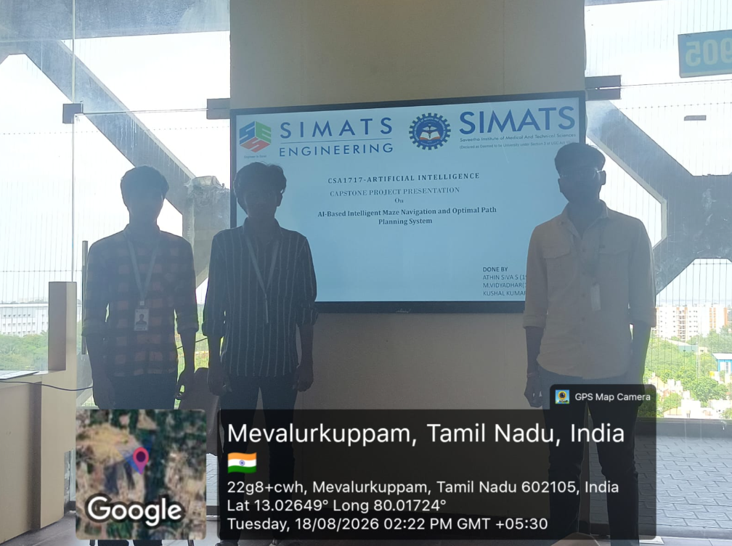
Project Description: This project focuses on the design and implementation of an AI-based intelligent maze navigation system for finding the shortest and most efficient path through a maze. Traditional maze-solving methods can be slow and computationally inefficient, especially when the maze becomes complex or contains obstacles. In this system, Artificial Intelligence and the A* search algorithm are used to analyze the maze environment and determine an optimal path from the starting point to the destination. The system generates maze environments, maps them into a searchable grid, detects obstacles, and dynamically updates the navigation path. The calculated route is displayed visually along with the maze, allowing the performance of the navigation system to be analyzed. This project demonstrates how AI-based search techniques can improve navigation efficiency, accuracy, and decision-making in applications such as robotics, autonomous vehicles, and smart automation.
Project Title: AI-Based Intelligent Maze Navigation and Optimal Path Planning SystemThe objective of this project is to design and implement an intelligent maze navigation system using Artificial Intelligence and the A* search algorithm. The project aims to generate maze environments and provide an efficient method for finding the shortest path between a starting point and a destination. It also focuses on detecting obstacles, updating the navigation path, and visualizing the optimal route in real time. By implementing this system, the project demonstrates how AI-based pathfinding can improve navigation speed, accuracy, and computational efficiency for applications such as robotics, autonomous vehicles, drone navigation, and automated systems.
Student Signature Guide Signature

